|  |
| --- |
| **Year 11 Specialist Mathematics**  Semester 2, August 2021  **Test 4: Trigonometric Functions and Identities**  **Calculator Free Weighting: 7%**  **[Australian Curriculum Reference Numbers: 2.1.1 - 2.1.9]** |

**Total Time: 50min Total Marks = $\frac{}{42}$**

**Student Name:**

**Teacher: ___________________________________**

**INSTRUCTIONS TO STUDENTS:**

* You **are not allowed** a calculator or any notes
* A formula booklet will also be provided.

You are required to attempt ALL questions.

Write answers in the spaces provided beneath each question.

Marks are shown with the questions.

**Show all working** clearly, in sufficient detail to allow your answers to be checked readily and for marks to be answered for reasoning. Incorrect answers given without supporting reasoning cannot be allocated any marks. For any question or part question worth more than two marks, valid working or justification is required to receive full marks.

1. Determine the value of the pronumerals for the following graphs.

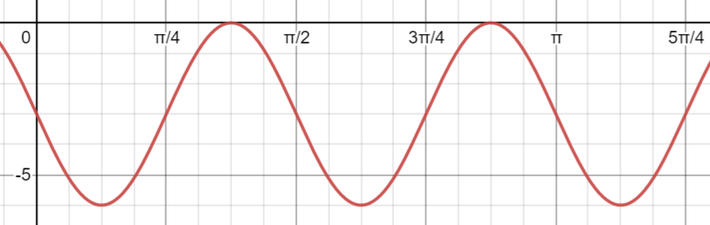

|  |
| --- |
|  |

|  |
| --- |
|  |

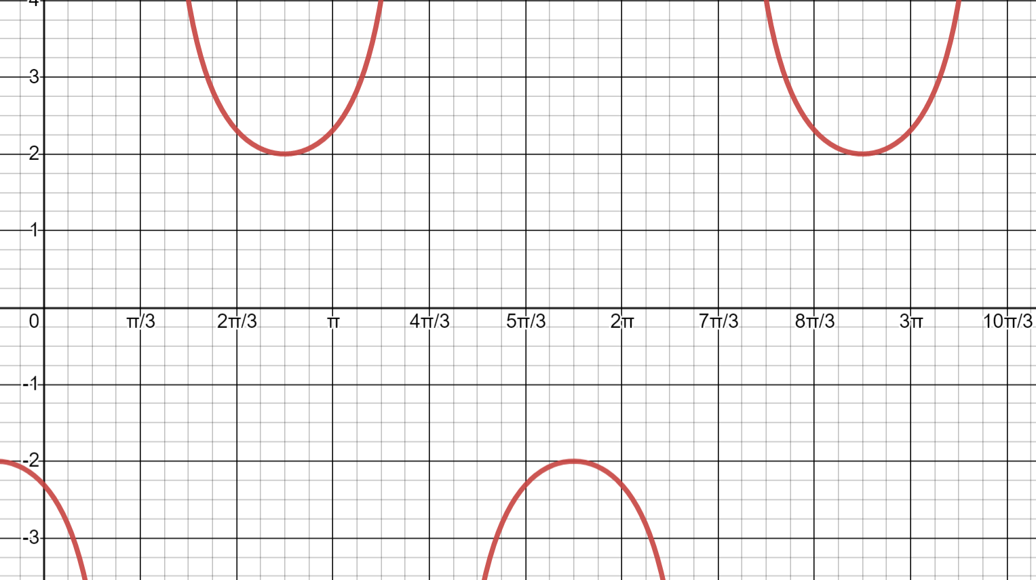

|  |
| --- |
|  |

[7 marks]

1. 1. Show that

|  |
| --- |
|  |
|  |
|  |
|  |
|  |
|  |

* 1. Hence, prove that $\tan\left(θ+\frac{π}{4}\right)= \frac{1+2\sin{θ}\cos{θ}}{1-2\sin^{2}{θ}}$

|  |
| --- |
|  |
|  |
|  |
|  |
|  |
|  |
|  |
|  |
|  |
|  |
|  |
|  |
|  |
|  |
|  |
|  |

[2,5 = 7 marks]

1. Determine the exact value of $cos ({\frac{11π}{12}})$. Express your answer with a rational denominator.

|  |
| --- |
|  |
|  |
|  |
|  |
|  |
|  |
|  |
|  |
|  |
|  |

[6 marks]

1. Solve the following trigonometric equations:

|  |
| --- |
|  |
|  |
|  |
|  |
|  |
|  |
|  |
|  |
|  |
|  |
|  |
|  |

* 1. as a general solution in degrees.

|  |
| --- |
|  |
|  |
|  |
|  |
|  |
|  |
|  |
|  |
|  |
|  |
|  |

**[7,6 = 13 Marks]**

1. Express the value of $\sin{75°}\sin{15°}$ as a single fraction.

|  |
| --- |
|  |
|  |
|  |
|  |
|  |
|  |
|  |
|  |
|  |
|  |

[3 marks]

1. Express $\sin{x}-\sqrt{3}\cos{x}$ in the form $R\sin{(x±∅)}$ and hence sketch the graph of: $$y=sin{x}-\sqrt{3}\cos{x}$$

|  |
| --- |
|  |
|  |
|  |
|  |
|  |
|  |
|  |
|  |

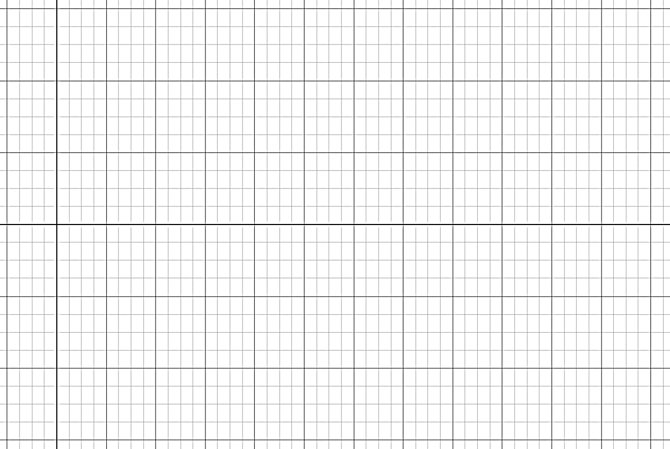

[6 marks]

*** End of Test ***

***Extra space for working out***

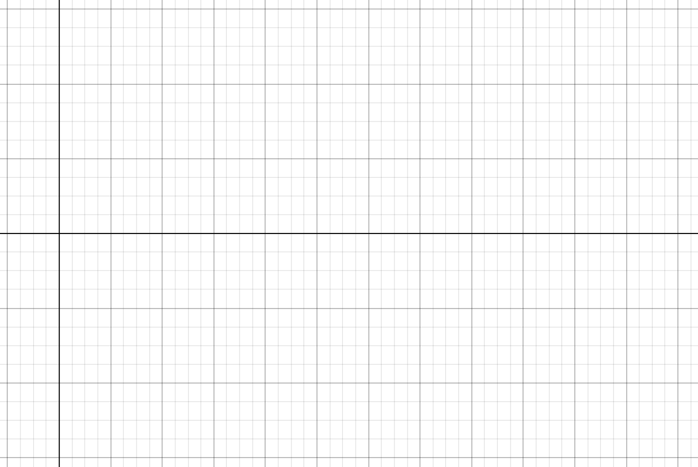

|  |
| --- |
|  |
|  |
|  |
|  |
|  |
|  |
|  |
|  |
|  |
|  |
|  |
|  |
|  |
|  |
|  |
|  |
|  |
|  |

***Extra space for working out***



|  |
| --- |
|  |
|  |
|  |
|  |
|  |
|  |
|  |
|  |
|  |
|  |
|  |
|  |
|  |